**Switch statement**

Switch is a conditional statement used to switch the value of the variable with another one. It used instead of using long code with if statement.

**Syntax:**

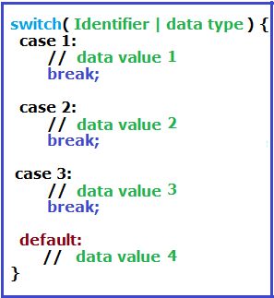

We write the identifier or its data type which we need to switch inside the parentheses of switch keyword.

We write the next statements inside brackets **{ }**

1. Case Keyword.
2. Break Keyword
3. Default Keyword

What happen is JS engine will take the value between () of switch and start to compare it with case statement from top to down until it reach the first case statement has a value stricky equal (===) the first value then the replacement process occurs and all rest cases were be ignored.. **both** the value and data type is compared with the values of each case below. If there is an identical (===), data type of this case will be placed instead of the expression .

**Note: Expression refers to data type between the parentheses of switch keyword ()**

**Example1:**

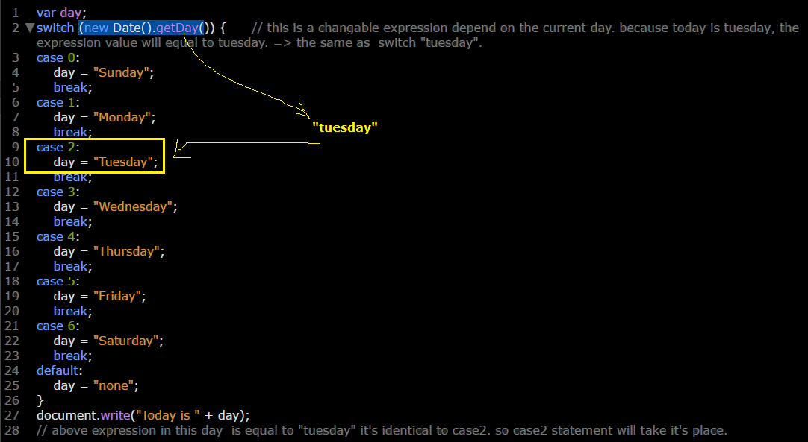

**Example2:**

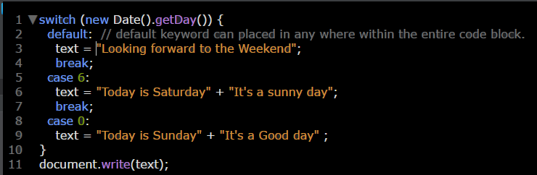

**Example3:**

